**SHOULD HERCULE POIROT MAKE A COMEBACK?**

-Prerna Kannan, Lady Shri Ram College

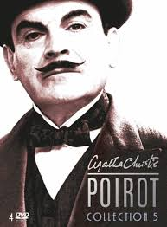

The famous Belgian detective with an egg shaped head might make a comeback. Agatha Christie’s famous character Hercule Poirot might get resurrected. I, for one, have mixed feelings about this news.

The Belgian and his famous grey cells will be revived by the crime author Sophie Hannah. Poirot last starred in ‘Curtains’ almost 40 years ago, and now he is coming back to solve more mysteries in the hands of Sophie Hannah.

A part of me doesn’t like the fact that Hannah is going to borrow the brilliant imagination of the most famous crime writer and give it new life. How is she being any different from the people who sell imitations of famous paintings? That is not where my problems with this idea end. What guarantee will she give that she will write a masterpiece at par or better than Christie’s? If she can’t make the book better what is even the point of writing the novel?

At the same time another part of me would like to read her version and see how she brews the plot of the story and characterizes Poirot.  Just like famous people have multiple biographies, written by different people, each giving a fresh perspective of the person, why shouldn’t famous literary characters also be explored through different angles? Hannah’s story might be more modern. Maybe Poirot, instead of enjoying his favourite cup of cocoa, might drink an ice cold beer.

I am eagerly anticipating the release of the new book! All the mysteries surrounding the outcome will come to rest after its release.

